

How to Dispose of Medicines Properly

DON’T: Flush expired or unwanted prescription and over-the-counter drugs down the toilet or drain unless the label or accompanying patient information specifically instructs you to do so.
DO: Return unwanted or expired prescription and over-the-counter drugs to a drug take-back program or follow the steps for household dis- posal below.

1ST CHOICE: DRUG TAKE-BACK EVENTS
To dispose of prescription and over-the-counter drugs, call your city or county government’s household trash and recycling service and ask if a drug take-back program is available in your community. Some counties hold household hazardous waste collection days, where prescription and over-the-counter drugs are accepted at a central location for proper disposal.

2ND CHOICE: HOUSEHOLD DISPOSAL STEPS*

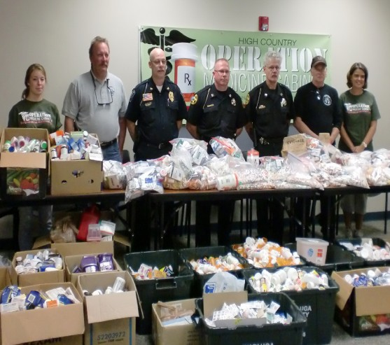
Drug Take-Back Event
Courtesy: Upper Watauga Riverkeeper and Appalachian Voices

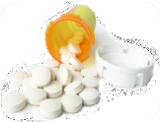
- Take your prescription drugs out of their original containers.

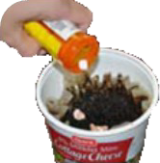
- Mix drugs with an undesirable substance, such as cat litter or used coffee grounds.

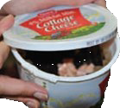
- Put the mixture into a disposable container with a lid, such as an empty margarine tub, or into a sealable bag.

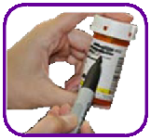
- Conceal or remove any personal information, including Rx number, on the empty containers by covering it with permanent marker or duct tape, or by scratching it off.

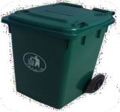
- The sealed container with the drug mixture, and the empty drug containers, can now be placed in the trash.

* Drug Disposal Guidelines, Office of National Drug Control Policy, October 2009

How Proper Disposal of Medicines Protects You and the Earth:



Prevents poisoning of children and pets Deters misuse by teenagers and adults
Avoids health problems from accidentally taking the wrong medicine, too much of the same medicine, or a medicine that is too old to work well
Keeps medicines from entering streams and rivers when poured down the drain or flushed down the toilet

How Improper Disposal of Medicines May End Up in Our Drinking Water Sources
In homes that use septic tanks, prescription and over-the-counter drugs flushed down the toilet can leach into the ground and seep into ground water.
In cities and towns where residences are connected to wastewater treatment plants, prescription and over-the-counter drugs poured down the sink or flushed down the toilet can pass through the treatment system and enter rivers and lakes. They may flow downstream to serve as sources for community drink- ing water supplies. Water treatment plants are generally not equipped to routinely remove medicines.

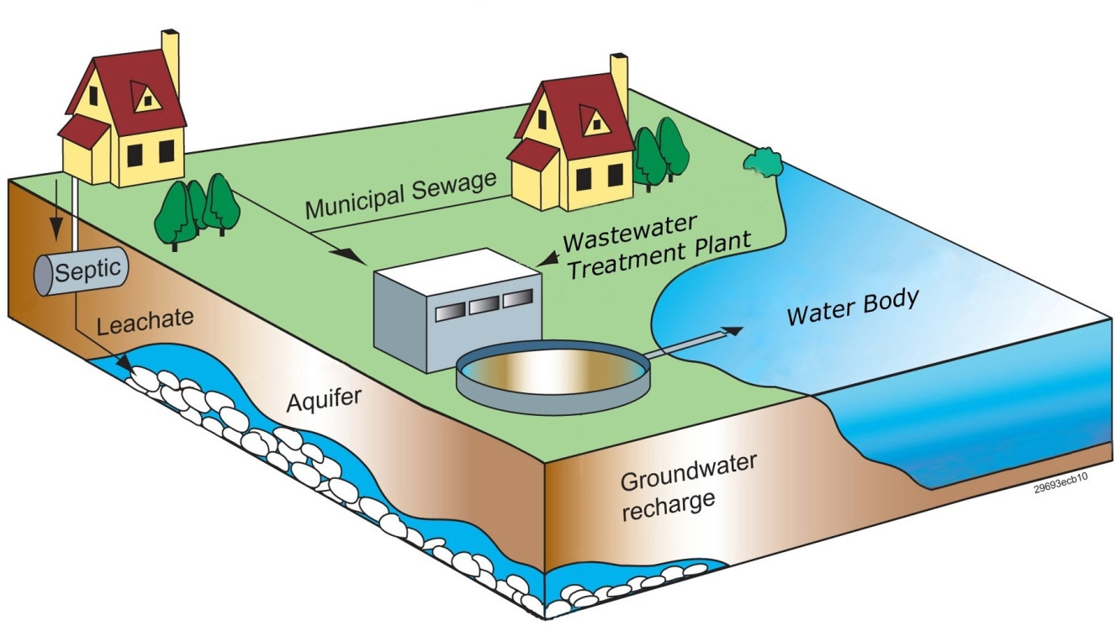

For more information, go to www.epa.gov/ppcp/
Or call the Safe Drinking Water Hotline at 800-426-4791
Office of Water EPA 816-F-11-003 April 2011

